Award Update

The FBEU featured in an article published in the SMH today, speaking to the Union’s 20% wages claim for the 2024 Award. You can find the article here and via the Union Facebook.
The article speaks to the increasing demands placed on professional firefighters across the state and notes the Minn’s Governments recent announcement to dramatically increase new dwellings as just one of many factors adding to the challenges FBEU members face on the job.
Since 2017, the value of the statistical life, property, and infrastructure protected by professional firefighters has increased dramatically. As evidenced by data from the Australian Bureau of Statistics, this includes an average annual increase of 10.2% in the value of NSW dwellings, and 8.5% in the value of NSW infrastructure. The NSW population has also boomed in this time.
However, the increasing value of assets we protect isn’t our only challenge. Significant issues in the construction of building, including that of unrectified cladding, and the prevalence of lithium-ion battery fires, are impacting on firefighting operations and causing greater risk to life, including that of firefighters.

Then there’s the escalating occurrence of major natural disasters, the impact of climate change, the doubling of our ‘assist ambulance’ calls, and the list goes on. At the same time, our numbers haven’t changed one bit.
FBEU members are consistently being asked to do more with less. And yet, our performance and our ongoing commitment to the job continues to lead to quality outcomes for the Government and cost-effective outcomes at that.

For these reasons, among others, we say this is evidence of reasonable purchasing power for real wage growth.

But the hurdle continues to be the Minns Government, who weeks out from the expiry of our Awards, still haven’t provided FRNSW with bargaining parameters.
At this stage, the Governments ‘new’ IR system re-brand is shaping up to be as disingenuous as the FRNSW Plus Plan.
Further updates to follow shortly.
Retained Alerting
Further to matters raised in Sitrep 20/2021, FRNSW has this week confirmed that for any call that is received at a Retained or Mixed station, pagers will be set off in all circumstances.
Comms operators have the option of “alerting” a station when an appliance is assigned to a job, or simply “assigning” the appliance without alerting the station. In some circumstances, such as the submission of a white message or subsequent jobs, it can make sense to “assign” an appliance rather than alerting them and setting off the bells.

At a Retained or Mixed station however, this means that any Retained staff who aren’t on the appliance don’t know about the job and can’t respond to the station to be paid and to contribute towards their percentages. Operational Communications is in the process of implementing a change to ensure that all incidents attended by any appliance at a Retained or Mixed station will cause the bells to go off, the station to be alerted, a timesheet to be generated, and the appropriate notification to all Retained Firefighters attached to that station, in order for members to be paid.

It is expected that FRNSW may take a few weeks to implement the changes, but starting next month, if you are at a Retained or Mixed station and you are not alerted to an incident that any appliance at your station attends, write to us at office@fbeu.net with the details.

Seniority at Retained Stations

Recent industrial inquiries have prompted clarification concerning seniority at Retained stations where a member has transferred from elsewhere. The 2023 Award at clause 25.6 states, "When an employee is transferred to a new brigade, the employee’s seniority in the new brigade will be determined as if that employee had always been with the new brigade, that is, by length of continuous service with the Department."
If these circumstances require local clarification, please reach out to your Duty Commander in the first instance and contact the Union office if any issues persist.

In Unity
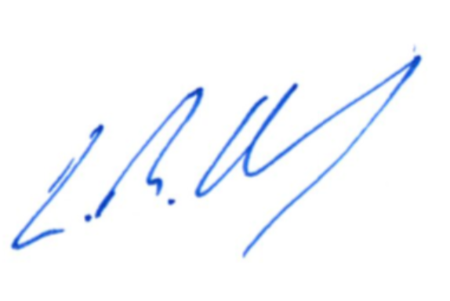
Leighton Drury
State Secretary

