Respect, Protect, Value – Campaign T-Shirts

Code Reds from 25 Feb remain in place, with members instructed to cease wearing FRNSW issued T-shirts/shirts while performing any work or duties for FRNSW and instead to wear any other shirt including but not exclusive to union and/or industrial campaign t-shirts or Hawaiian Shirts.
A new member t-shirt displaying the industrial campaign slogan of ‘Respect, Protect, Value’ are en route to the FBEU Office and are now available for members to order via the following process.

- Get an FBEU delegate or designated member to collate your whole station order using this from here
- Upload/submit the order and provide further details via this survey link

All shirt orders will be sent to the respective station or nominated address OR through your SCOM rep, depending on location. Please note, only orders collating all FBEU members at station will be accepted. No single shifts.
In the meantime, members are encouraged to continue wearing existing union shirts OR other non-FRNSW shirts in accordance with the Code Red.
If any member is concerned that any of the Code Red activities pose a risk to your own health and safety, the safety of a colleague, or any member of the community, you should stop and contact us immediately.
In Unity
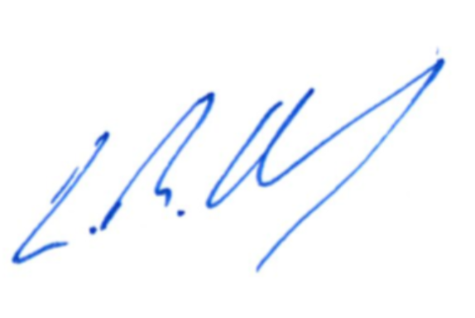
Leighton Drury
State Secretary

