AWARD UPDATE
Alongside representatives from the Premier’s Department and Public Sector IR, the FBEU and FRNSW met yesterday to further “negotiations”. Despite ongoing without prejudice discussions, FRNSW remain unable to provide a wage offer nor put any formal proposals on the table to enable real bargaining to occur.
As a result of these circumstances, campaign action will continue to escalate. See below.
INDUSTRIAL CAMPAIGN NEXT STEPS – SAVE THE DATE
Next week is the final sitting week for the Minns Government until May and it is imperative that we send a strong message. As such, the Union call on all available off-duty members to rally next Wednesday 11am at Parliament House, Sydney, meeting at the rear of Parliament on Hospital Road for briefing prior to marching on Macquarie Street.
Work is underway to provide transport options for members residing outside of the Sydney Metro area. Those details will be provided as soon as possible.
RESPECT, PROTECT, VALUE YOUR FIREFIGHTERS
On Wednesday I attended State Parliament to meet with MP’s from across the political spectrum, continuing our call for improvements to presumptive cancer legislation. I was honoured to be joined by Comrades Bob McGowan and Matt Carroll, both intergenerational firefighters who have been impacted by occupational cancers outside of the current presumptive coverage.
On behalf of the State Committee, we express our sincere gratitude to Bob and Matt, whose advocacy in this space is not only honourable but essential to the safety of generations of firefighters to come.
But while the Union was making in-roads to ‘Cover our Firies’ from workplace cancers, work was being done in a separate room of Parliament to spread inaccurate propaganda in a bid to demonise FBEU members and this campaign.
The blow came from the Hon. Anthony D’Adam, a short-lived Trade Union staffer, and current Parliamentary Secretary for Emergency Services.
In response to a motion concerning the status of our Awards, D’Adam went out of his way to accuse members of getting in bed with the “devil”, noting that the motion was indicative of the Liberal Party “doing the bidding” of the FBEU. See transcript for the full dialogue.
For context, the motion was moved by Liberal opposition member the Hon. Damien Tudehope. Having suffered from 10+ years of wage stagnation under Mr. Tudhope’s Government, members will recognise that he is no friend of the FBEU. Nonetheless, his points concerning inaction around our negotiations are important and need to be answered.

And this is where D’Adam misses the point. He, and other members of the Minns Government, should be focussed on fixing the industrial relations debacle which is the legacy of Mr. Tudehope and the previous Liberal Government. That’s what the Minns Government said they would do, it’s what they aren’t doing, and it’s the reason FBEU members are escalating our campaign next week.
FBEU members have had a gut-full and we’ll be reminding D’Adam of why on Wednesday.

ESA RESTRUCTURE

The FBEU is aware that Senior Management at the ESA have advised employees of a proposed restructure. We wish to be clear that formal consultation on any proposals have not commenced and we have not endorsed nor agreed to any change. The FBEU’s current position is that all current arrangements should remain in place and any proposals should be fully consulted with us in accordance with the Award. We have communicated this to FRNSW. If any members has any concerns in the meantime please contact the FBEU office directly on office@fbeu.net

In Unity
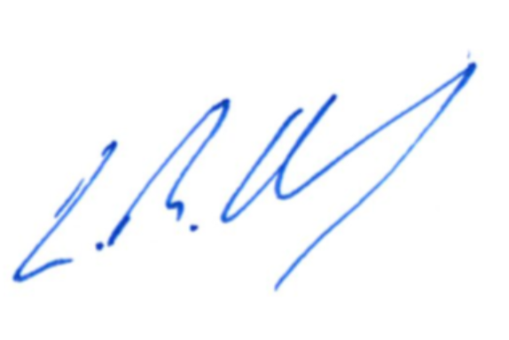
Leighton Drury
State Secretary

