FBEU MEMBER’S RALLY IN NUMEBR’S AT STATE PARLIAMENT

On behalf of the State Committee, President Mick Johnsen and I extend our sincere appreciation to all the FBEU members and their families who attended the FBEU rally at State Parliament yesterday. See here for a video message.
Your participation demonstrates a dedication and commitment to our Union values and to our current struggle. If we don’t turn, we don’t win. It’s as simple as that.
In addition, we thank the broader NSW Union Movement for showing up in solidarity to support members, particularly the Public Service Association, United Services Union, Teachers Federation and Unions NSW. Your struggle is our struggle.
FBEU members were heard loud and clear yesterday, so much so that the State Government were forced to discontinue question time. See here for some of the action.

THE MINNS GOVERNMENT HAS FAILED TO SUPPORT PROFESSIONAL FIREIFGHTERS IN THEIR CALLS FOR A FAIR OFFER.
In the media yesterday, the Premier referred to us as “tough negotiators” who “belt the Government around”. And yet, the Minns Government are no closer to a resolution.
This was the third rally at State Parliament and, as promised, the FBEU will continue to escalate this campaign until the Minns Government listen. Respect, Protect, Value Your Firefighters.

AWARDS BACK BEFORE THE IRC
As member action escalates, we were also back before the Industrial Relations Commission this morning on our Award applications.

Commissioner McDonald heard and understood our continued argument that FRNSW & the Government must come to the table with wages offer for negotiations to progress.

She has asked that the parties continue our Award negotiations for a further 3-week period indicating that post that period she is inclined to issue a recommendation seeking that FRNSW make wages offer if one is not forthcoming prior. We are relisted for conciliation on 11 April, and we will be meeting with FRNSW as much as possible prior to that to do all we can to continue to reach an outcome.

Meanwhile I can confirm that following on from yesterday’s action and the outcome of the IRC this morning I also spent time in Parliament today meeting with relevant Government officials and can report that our message is heard across the board.

In Unity
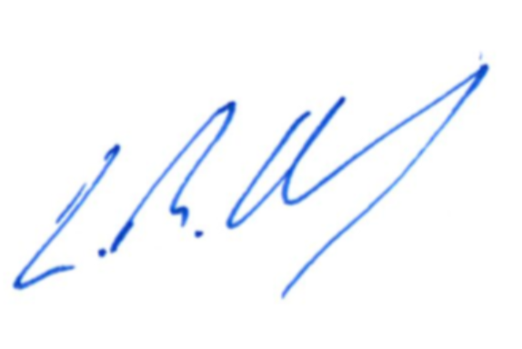
Leighton Drury
State Secretary

