PRESUMPTIVE CANCER LEGISLATION UPDATE
On Monday, Minister Sophie Cotsis wrote to FBEU members with an update concerning our presumptive cancer campaign. In the letter here, Minister Cotsis expresses her sincere thanks to members Matt Carrol and Bob McGowan who recently attended Parliament with myself in March to share their personal stories with occupational cancer.
According to the Minister, the message from FBEU members has been heard and further considerations for the expansion of presumptive legislation in NSW are progressing with ‘all expedience’.
As members know too well, we need actions not words from the Minns Government. Actions related to the Respect, Protect, Value campaign including Code Reds maintain in place.

MAY DAY 2024

Disappointingly the independent May Day committee facilitated by Unions NSW has made the decision not to proceed with the usual Sunday Sydney May Day March, instead promoting a mid-week rally on Wednesday 1st May. As such, the FBEU will instead be promoting member attendance at this year’s Newcastle and Wollongong events.
May Day is a great day of solidarity across our movement and a great opportunity to show strength. We encourage all members and their families to attend.
Wollongong May Day – Assemble at 10am Saturday 4th May
Where: Lowden Square, directly opposite Wollongong Train Station (eastern side)
Newcastle/Hunter May Day –10am Sunday 5th May
Where: Newcastle Museum, Newcastle East
If members wish to march in Sydney at 10:30am Wednesday May 1st they can participate in a March run by Unions NSW. See here for details.

In Unity
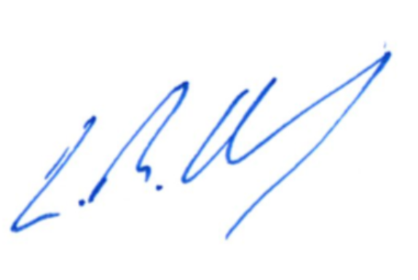
Leighton Drury
State Secretary

