HSR POWERS AND PAYMENT WIN
Last week, the IRC ordered FRNSW to pay a Retained Health & Safety Representative (HSR), with FRNSW arguing unsuccessfully that the HSR required permission to undertake workplace inspections. The IRC Commissioner ruled that the performance of the HSR’s work, undertaken proactively on behalf of the MN3 workgroup, was lawful, and that FRNSW therefore had an obligation to renumerate the HSR under the Work Health & Safety Act.
The decision comes 19 months after the HSR lodged a provisional improvement notice (PIN), exercising their powers under the WHS Act to notify FRNSW of a contravention. The PIN was also twice rejected by Safe Work NSW on internal review prior to the FBEU escalating the matter to the IRC.

Under cross-examination, the FRNSW fared poorly in front of the Commission, arguing that it should be up to management to decide how and when a safety matter is addressed. The position, at complete odds with the intentions of the WHS Act and the powers of elected HSR’s, is yet a further demonstration of FRNSW failing in their most basic obligations to FBEU members.
While minor in scale, this decision reinforces the rights of FBEU members to democratically elect HSR’s and for HSR’s to enact powers under the WHS Act without interference from management. Given the dangerous nature of our work, this decision should not be taken lightly by management.
Members can read the full decision here.

RALLY IN WOLLONGONG THIS FRIDAY

Members are encouraged to join the Illawarra Sub-Branch this Friday in a further escalation of our bargaining dispute. The Union will be meeting at the office of Paul Scully MP at 11am. The details are as follows:

Time: Friday 5 July, 11am
Location: 51 Crown Street, Wollongong
Contact point: ISB SCOM Rep Andrew Clark, 0425 330 139.

In Unity
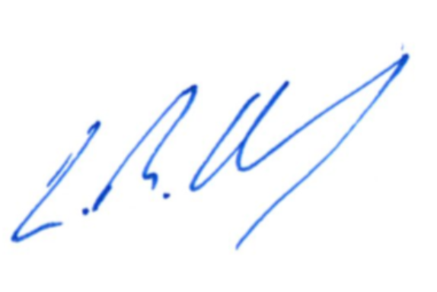
Leighton Drury
State Secretary

